PROJECT TITLE
LIFECYCLE EXTENSION THROUGH PRODUCT REDESIGN AND REPAIR, RENOVATION, REUSE, RECYCLE STRATEGIES FOR USAGE&REUSAGE-ORIENTED BUSINESS MODELS

PROJECT ACRONYM
T-REX

CALL IDENTIFIER
ICT-FP7-2013-NMP-ICT-FoF

PROJECT N.
609005
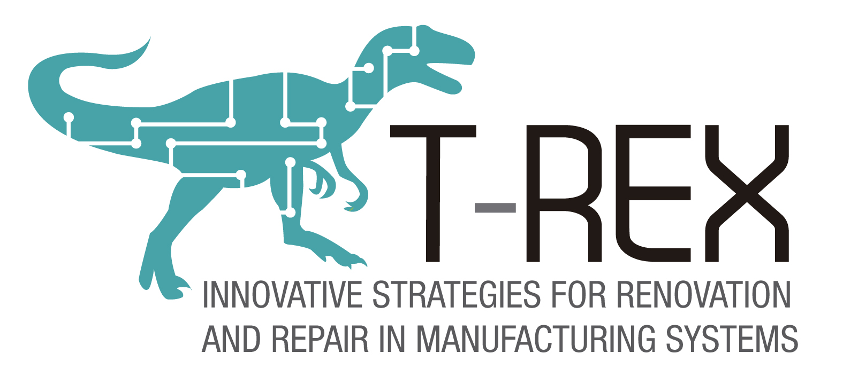

Objective and value
T-REX is a project funded by the European Union under the 7th Framework Programme (http://t-rex-fp7.eu ). It involves 11 partners overall. The project aims at developing:
- new, usage-oriented business models in capital goods industries, where what is sold is the access, functions and outcomes of a product rather than the ownership; “);
- methods and tools to implement them in the service engineering, product design and fleet operations and maintenance areas
This survey aims to investigate the business priorities and the service business development of European firms competing in capital goods industries and to highlight benefits and obstacles to the adoption of service-based business models.
A report of the survey results will be provided to all respondents, as well as updates on the following steps and results of the T-REX project.
The survey has been prepared by University of Brescia (Italy), with the collaboration of IK4-Tekniker (Spain), Fraunhofer IAO (Germany) and Predict (France).

Guidelines
The survey structure is based on business model Canvas (see Figure below).
A specific set of question will be asked for each building block in the following pages.

This survey is mainly addressed to Service and Sales Managers: please don't hesitate to involve any other colleagues wherever necessary.
You can fill in the survey in different steps: during the compilation you can exit and re-enter using the same link.
In order to save your answers, please be sure that you have completed all the questions presented in a page
Compilation estimated time: 20 min.
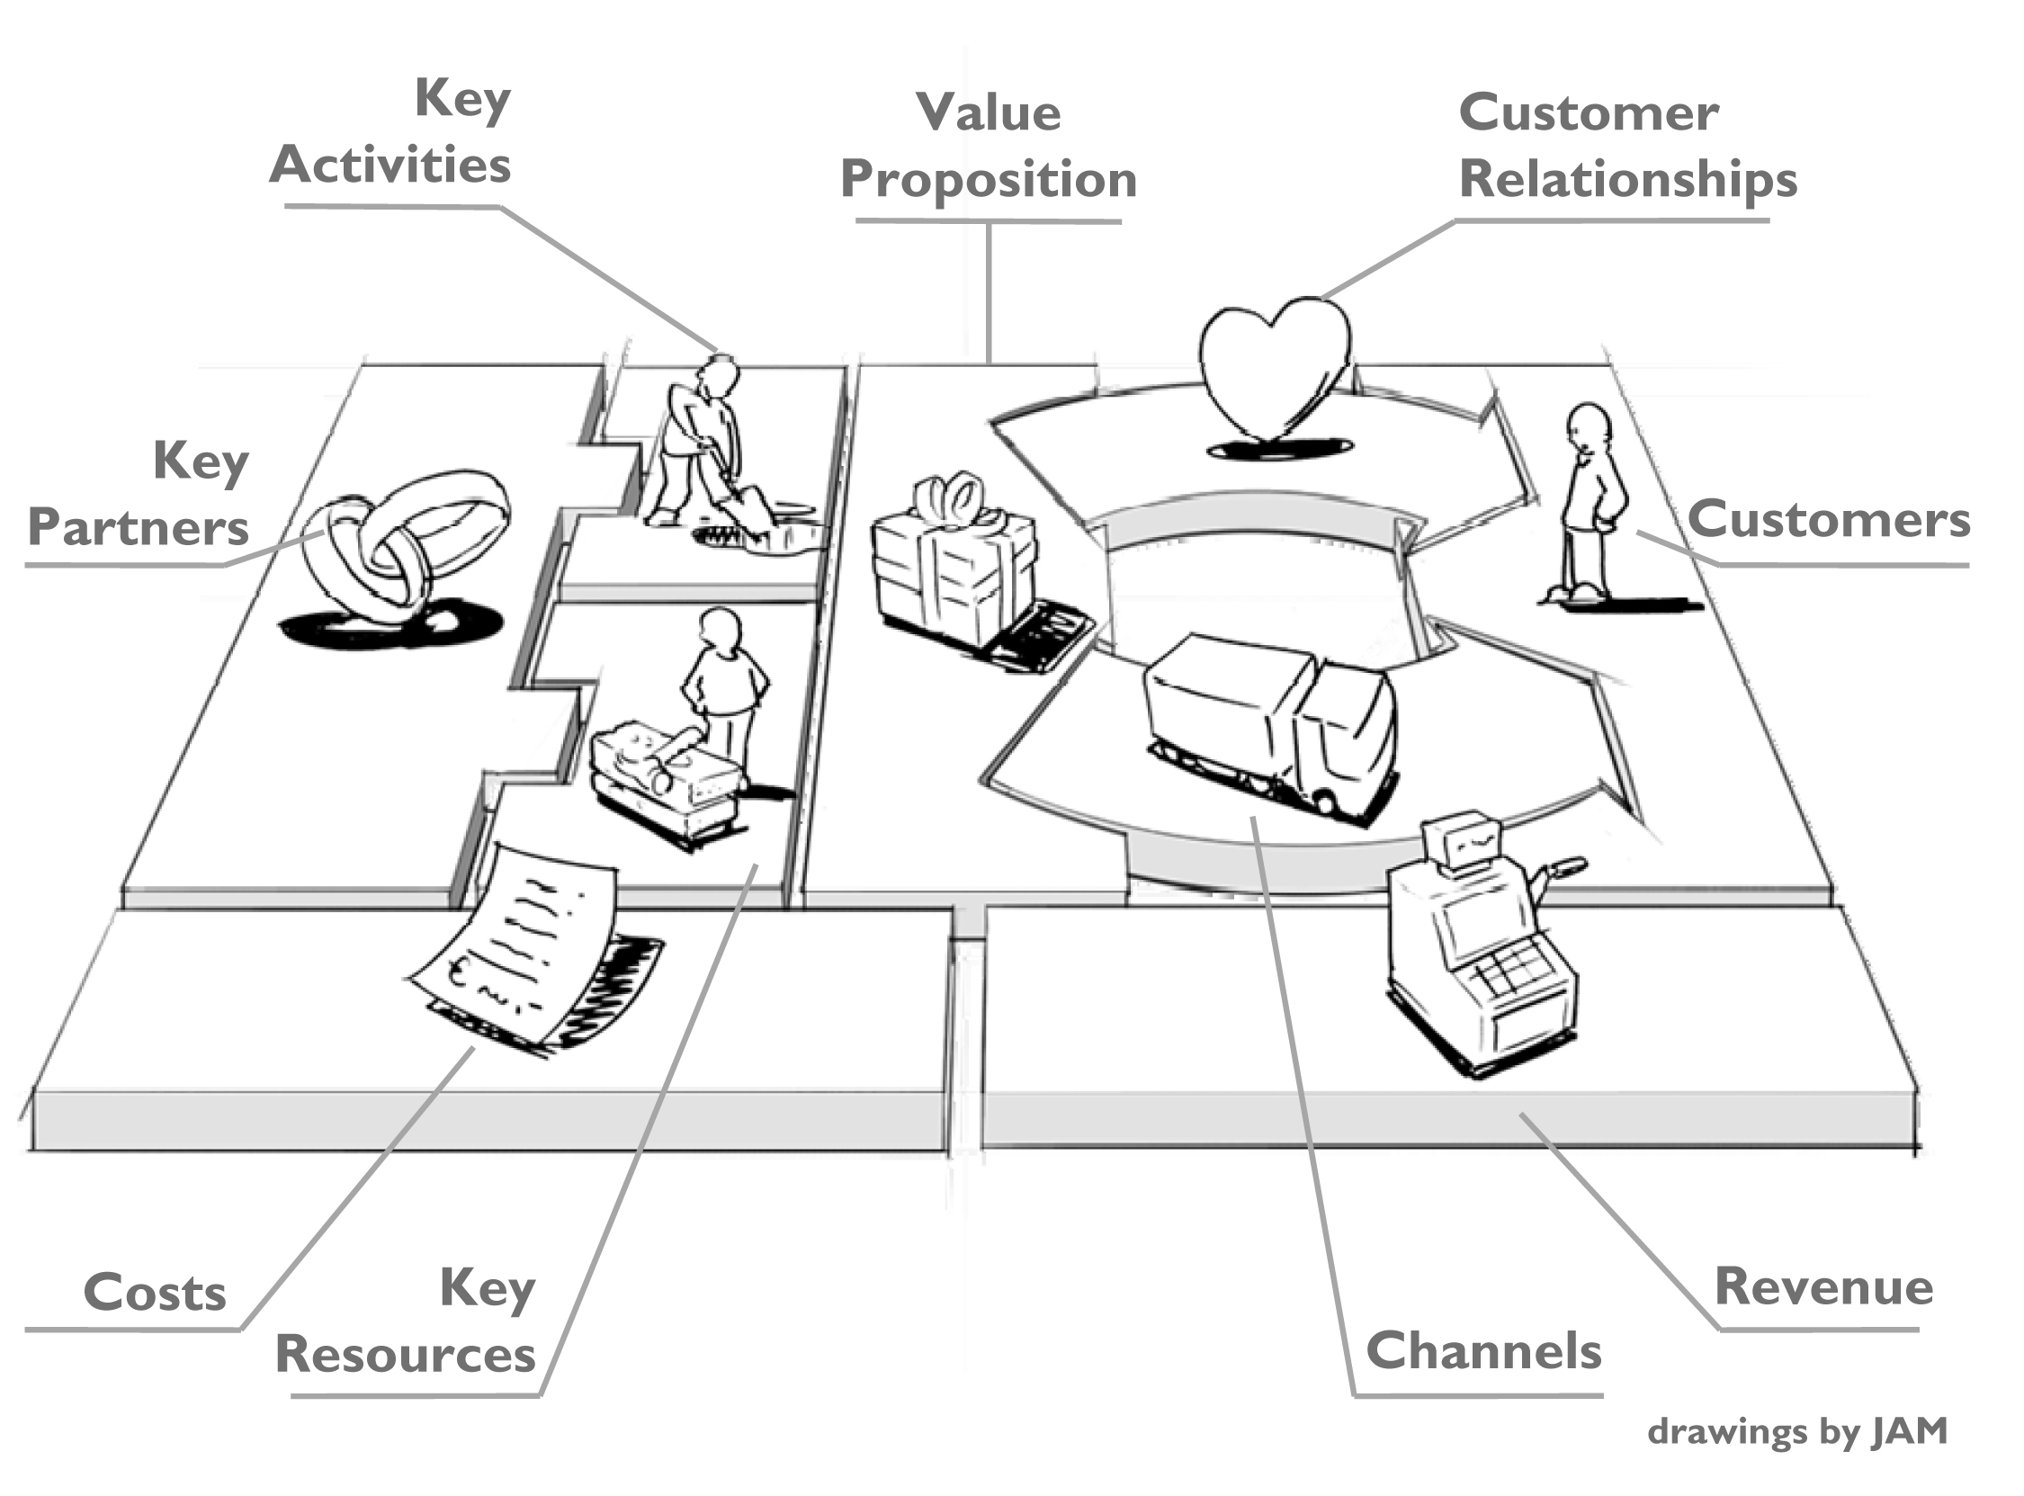
Fig. 1: Business model canvas

Confidentiality
The survey will be presented in anonymous format.
Data provided will be used only for research purpose by research institutes involved in T-REX project (http://t-rex-fp7.eu/index.php/partners).
This research may results in publications in journals or conference proceedings.
Once completed by responding directly in this document, please, send the document to the following address nicola.saccani@ing.unibs.it.
In case you’d prefer to complete the survey on the internet, it is also available on the following link https://www.surveymonkey.com/s/BKHY5HL.
Thank you very much for your participation.

List of questions

Respondent and company data
Please fill this section with data of the main respondent.

Company name

Company website

Name

Surname

Email address*

Telephone number

Role in the company

Company size: number of employees [2012]

Company size: approx. turnover [2012]

Customers

What is the importance of the following customer segmentation criteria that you use/don’t use? [use Y/N; importance 1-5]
- Revenue generated by customers from product sales
- Profit generated by customers from product sales
- Revenue generated by customers from services purchasing
- Profit generated by customers from services purchasing
- Status and reputation of the customers (brand relevance)
- Geographical location of the customers (e.g. Country, continent)
- Customer supply chain positioning (e.g. OEM, End user, etc.)
- Industry sectors
- Customer size (revenue and/or employees)
- Other (please specify…)

How often are your customers typically involved in the design phase of your products? [never, very rarely, Sporadically, Frequently, Very frequently] *

How long has your company offered these tools to customers? [since 10 years or more; since more than 5 years but less than 10; since more than 2 years but less than 5; since less than 2 years; not offered]
- Web-based applications to monitor products/system or health state
- Web-based applications to place spare-parts orders
- Web-based applications to open and manage tickets for service requests and activities

Channels

What is the importance of the following ways to help customers in the evaluation of your offer in the pre-sales phase? [level of importance 1-5, with the option to skip options] *
- Comparison of technical performance with competitors
- Use cases of existing customers and performance they achieved
- Service level agreement
- Total cost of ownership assessment
- Reliability assessment
- On-site visits to best-in-class customers
- Open house
- Other (please, specify)

How does your company provide customer support after the sales? [Completely internal; Mainly internal; 50/50; Mainly outsourced; Completely outsourced; with the option to skip options=none] *
- Handling customer request
- Remote diagnosis
- Technical assistance planning (corrective maintenance)
- Technical assistance execution (corrective maintenance)
- Preventive/Predictive maintenance

Value proposition

In your opinion, how much value is attached by customers to the following aspects of your offer? [1-5 scale] *
- Brand reliability
- Product performances
- Product expected lifetime
- Product flexibility (in terms of capabilities to adapt to different tasks)
- Product productivity
- Customers image enhancement
- Customers minimization of costs
- Customers minimization of operational risks
- Customers minimization of maintenance efforts
- Others (please specify)

Which of the following services does your company offer to your customers? [Not offered; Yes, rarely; Yes, sometimes; Yes, often; Yes, always] *
- Optimization of customer processes
- Financial services
- Rental services
- Leasing services
- Second-hand products
- Pay-per-use contracts
- Warranty extensions
- Maintenance contracts
- Repair
- Spare parts
- Documentation
- Basic training
- Advanced training
- 24/7 technical assistance
- Product remote monitoring
- Remote diagnosis
- Product mechanical, hardware and/or software upgrade
- Product mechanical, hardware and/or software retrofit
- Relocation
- Product disposal
- Consultancy services (not related to your product enabled processes)
- Other (please specify)

Which is the average age of your products when your customer decides to substitute them (years)? [value]

How would you rate in % the degree of customization of the “typical” product? [intervals scale or exact value]

How does your company mainly answer to customer orders? [Radio button] *
- Engineering to order
- Make to order
- Assembly to order
- Make to stock

Which percentage of your typical product is composed by modules that can be also used in other products (product modularity)? [intervals scale or exact value]

Which percentage of reusable modules are Line Replaceable Units (components designed to be replaced quickly at the customer’s location)? [intervals scale or exact value]

What information do you use in order to decide if a component of an exhausted product can be reused? [Multiple choice]
- Global usage information
- Manual inspection of disassembled component
- Test and calibration
- Other

Key activities

Which is the expertise of your company on the following aspects? [level of maturity 1-5]
- Evaluation of your product total cost of ownership
- Adoption/development of models to simulate the total cost of ownership of your product during the design phase or the pre sales phase
- Measure of reliability of product sub-systems
- Adoption of sub-systems reliability target in the design of the product

How important are the following activities within your company? [level of importance 1-5, with the option to skip options] *
- R&D on products
- R&D on services
- Product design
- Product component purchasing
- Production/assembly
- Marketing activities
- Pre-sales commercial activities
- After-sales service activities

To what extent do you agree with the following statements regarding your service business? [Strongly disagree; 2; 3; 4; Strongly agree] *
- Services are an important part of our today’s business.
- The importance of our service business will increase in future.
- We have an explicit strategy for our existing services.
- We have an explicit strategy for our new services.
- We have defined responsibilities for the development of new services.
- We have a defined budget for the development of new services.
- We have a defined formal process (e.g. stage gate) for the development of new services.
- We have defined methods and tools for the development of new services.

Which is the level of adoption of the following product design techniques within your company? [1-5 scale]
- Design for reliability
- Design for maintainability/serviceability
- Design for life-cycle
- Design for reuse/recoverability
- Design for durability

Which of the following activities does your company perform in the field of fleet operation and maintenance in % of the total installed base? [(0-never ; 100- always)] *
- Corrective maintenance (on client demand)
- Corrective maintenance (under contract or warranty)
- Preventive maintenance (under contract or warranty)
- Predictive maintenance (under contract or warranty)
- Remote diagnostics
- Product condition analysis (using information from customer assessment and analysis of usage and performance of the product)

Which of the following information is regularly available to you (remotely, on a regular manual inspection basis,…) of existing installed product base over a % of total ? [(0-never ; 100- always)] *
- Failure modes and effects (especially for components that are part of your final system/solution)
- Maintenance activities carried out
- Usage of the product (e.g. How many hours working)
- Performance of the product (e.g. How many hours at maximum load - overloaded)
- Health condition of the product

How much these typologies of failures affect your products? [1-5 scale]
- Random failures that can appear at any time during the lifetime of the product (e.g. electronic products)
- Infant mortality (e.g. due to assembly or manufacturing issues)
- Steady increase of failures as the life of the product progresses (e.g. slow wear mechanisms)
- Sharp increase of failures at the final stages of the expected product lifetime
- Other (please describe)

Key resources

Which is the number of your products/systems/production lines:
- Currently installed worldwide (approximate figure)? [exact value]
- Generating service revenues(approximate figure)? [exact value]

Which of the following information systems does your company use to collect and manage data related with installed base? [Y/N] *
- Database (e.g. Oracle, MySQL, MS Excel, MS Access, Filemaker, others)
- PDM (Product data management system)
- PLM (Product lifecycle management system)
- CRM (Customer relationship management system)
- ERP (Enterprise resource planning system)
- SCADA systems
- Others (specify)

Key partners

Which is the average duration of the relationships with your suppliers? [Short term, 2, 3, 4, Long term]

Which is the strategy of your company regarding the number of suppliers? [Few, 2, 3, 4, Many]

Cost structure

How much do the following aspects impact on the cost structure of your company (considering investments, cost personnel, physical asset)? [1-5 scale, skip]
- R&D
- Product design
- Service design
- Purchase
- Production
- Sales/Marketing
- Service
- ICT

Revenue streams

Indicate the percentage of the total annual revenue generated by the following aspects: [estimated % breakdown]
- Products sales
- Financing/Leasing
- Product renting
- Product usage fee (pay-per-use or pay-per-performance contracts)
- Spare parts sales
- Technical assistance
- Service contracts (preventive/predictive maintenance contracts)
- Others

Has your company ever thought to offer pay-per-use/performance/availability contracts instead selling the product? *
- Yes, we already offer these kind of contracts
- Yes, but we don’t offer them yet
- No

What kind of contracts do you offer? [Y/N] *
- Pay-per-use
- Pay-per-availability
- Pay-per-performance
- Any other (please specify)

Which of the following are the most important reasons to offer pay-per-use/performance/availability contracts instead of selling the product? [level of importance 1-5] *
- Customers asked for these contracts
- To achieve a competitive advantage over competitors
- To strengthen the relationship with customers (lock out competitors)
- To make our life-cycle service offering tangible for the customers
- Other (please specify)

Which of the following are the most important obstacles to offer pay-per-use/performance/availability contracts instead of selling the product? [level of importance 1-5] *
- Increasing risk
- Product usage condition data collection
- Condition monitoring capabilities
- Service engineering capabilities
- Service orientation attitude of service personnel
- Service culture aversion of sales personnel
- Customer culture
- Our Company culture
- Other (please specify)

